**2xjdtozl%5b1%5d3b2hrpmk[1]Hey Kids Vacation Bible School is here!**

**July 10th-13th**

b3cj0saj%5b1%5d**8:30 -12:00 Noon**

**Fun Bible stories! Games! Prizes!**

**Snacks! Songs!**

**Free cookout, water games and awards ceremony on the last day!**

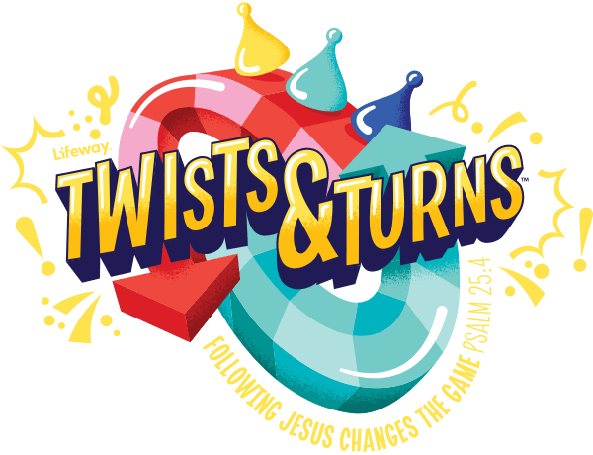**[](http://www.bing.com/images/search?q=waterballon+pictures&qpvt=waterballon+pictures&FORM=IGRE#view=detail&id=6ADAA0098197AB55E88E7E6C693F72A99C9ADEBF&selectedIndex=68#view=detail&id=6ADAA0098197AB55E88E7E6C693F72A99C9ADEBF&selectedIndex=68)[](http://www.bing.com/images/search?q=grill+cookout+clip+art&qpvt=grill+cookout+clip+art&FORM=IGRE#view=detail&id=7D3F7AB823AEE64F9B926F1B382220167EF45B5F&selectedIndex=44#view=detail&id=7D3F7AB823AEE64F9B926F1B382220167EF45B5F&selectedIndex=44)Come join the Fun as we learn How Following Jesus changes the Game!**



u3pr0v2v%5b1%5d

syaxjpzh%5b1%5d

**3 years old up to 6th grade**

**Parents are welcome to attend Y hablamos Espanol**

**Sponsored by Westside Community Church 201 E Sunset next door to the Westside police substation off Doniphan and Mesa**

**For more information** contact the church number at 877**-8000, 915 490 0288 or register online for free on our website**

[**www.westsidecommunity**](http://www.westsidecommunity) **.org**

